“They Laughed When I Put The
Tri-Creaser On My Folding Machine, But When They Saw The Results…”

“It’s so frustrating. Even the so called leading manufacturers haven’t come up with a creasing device that eliminates cracking on all materials.

And we have to out source most of our folding and creasing. It costs us thousands of pounds each year as well as hours and hours each week.”

Have you heard yourself saying the same things? Despite all the technological advances we’re making - no-one has solved the age old problem of fibre cracking. Okay some machines work 40-50 percent of the time - but is this good enough?

The Solution: A Simple And Very
Effective Device

We agree it’s unacceptable! So a few months ago we decided to search for the answer to the problem. We found an English inventor who seems to have “Cracked” it.

About 10 years ago he set about creating the revolutionary device. After 78 prototypes (yes, he didn’t give up easily) he finally achieved his goal. He created the ‘Tri-Creaser’ - a rotary creasing device that totally eliminates fibre cracking on materials ranging from 85 gsm to 350 gsm.

Our company has exclusive selling rights throughout Germany.

Already tens of thousands of printers and print finishers are benefiting from using the Tri-Creaser all over the world. Here’s what some of our first customer’s have said…

“Your Tri-Creaser is simple – easy to use, and works on a wide variety of stocks. It has saved me some £100 - £200 per week.”
Mr J Cole, Eden River Press Ltd

“The Tri-Creaser is simple to use with 100% quality. On average it saves us £30,000 per annum.”
Mr B Tucker, BRG Print Finishers

“The Tri-Creaser is very straight forward – operator picked it up quickly. 80% of our scoring is now done in house.”
Mr D Vokins, Hunts Printing

As you can see the Tri-Creaser is achieving startling results. And we have literally hundreds of comments like these from other customers all over the world!

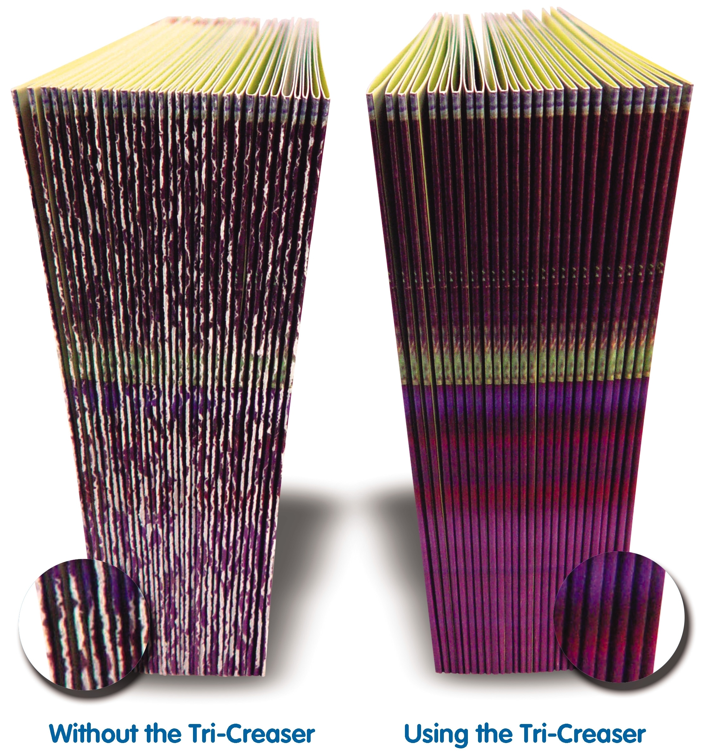

“Secret” Creasing Agent
Is The Key

So why hasn’t anyone made this “discovery” before?

That’s simple really. The Tri-creaser uses a “secret” specially formulated creasing agent that stretches the fibres (it does not crush them like all other methods). Therefore fibre cracking just isn’t “allowed” to occur.

You’re now probably thinking, “Great, no more cracking, but I bet it takes ages to set up!” Here’s the really good news…

Takes Just A Few Minutes
To Set Up

The Tri-Creaser takes just minutes to set up even by inexperienced operators. In fact the Tri-Creaser takes the skill out of quality creasing operations, so no one needs any training.

The operator is given simple instructions on how to adjust the settings to the stock thickness. All this takes is just a few minutes! Better still…

Attaches To All Popular
Folding Machines

The Tri-Creaser attaches to all popular makes of folding machine such as Heidelberg, Stahl and MBO and many more.
Here are some more important benefits…

- The Tri-Creaser does not need demonstration. It will start saving you time and money the moment you open it.

- All the settings (8 colour coded creasing options) are built in to the design so the Tri-Creaser is like having a very specialized operator working tirelessly for you, hour after hour, day after day, week after week - without the cost.

- The Tri-Creaser will crease as fast as your folding machine can run. It is 100% effective even over 25,000 sheets per hour!

- You’ll never have to outsource straight creasing jobs again. Massive savings in time and money!

- Superb for normal section work.

- Excellent on digital stock.

- Pays for itself on average between 1 and 3 job runs.

The Tri-Creaser also comes with a unique money back guarantee.

I’m not asking you to order today. Send for our FREE “Tri-Creaser Information Kit”. It will give you all the details. Only then do you have to make up your mind.

Call us now on 01455 554491 or complete the coupon below and post it to us at the address below. Alternatively visit our website at www.technifold.com.

Do it now. You really will be surprised at the vastly improved quality of your creasing work as well as the savings you’ll make!
Yes! Please send me your FREE
Tri-Creaser Information Kit.

Name: _________________________

Company: ______________________

Address: _______________________

_______________________________

Tel: ___________________________

Send To: Tech-ni-Fold Ltd, Unit 2,
St John’s Business Park, Lutterworth, Leicester, UK, LE17 4HB

